NutriGrow AI - Simplified Final Year Project Report

1. Introduction
NutriGrow AI is an intelligent system that combines Artificial Intelligence (AI) and Internet of Things (IoT) to grow exotic plants using hydroponics. It helps in efficient, sustainable, and automated farming.

2. Problem Statement
Traditional agriculture faces challenges such as high resource usage, climate dependency, inconsistent quality, and difficulty in growing exotic plants.

3. Objectives
- To automate plant growth using AI
- To reduce water and nutrient usage
- To monitor plants remotely
- To improve crop quality and yield

4. Methodology
The system uses sensors to collect real-time data (pH, temperature, humidity, light). AI models analyze this data and automatically adjust conditions using actuators.

5. System Architecture
Components:
- Sensors (pH, temperature, humidity)
- Microcontroller (ESP32)
- Cloud platform
- AI model
- User dashboard

6. Graph: Plant Growth Improvement
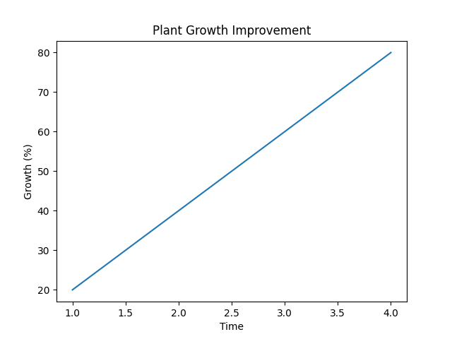

7. Results
- Faster plant growth
- 90% water saving
- Reduced crop losses
- Improved quality

8. Conclusion
NutriGrow AI provides a smart and sustainable solution for modern agriculture using AI and IoT.

